The problem with writing cool sample apps is that they have to be ported over to the new release. So I took the opportunity to make some improvements and show off the new API features.
Overview:
Effective Folder Permissions is a set of commands that allow you to view the folder permissions on a per-user basis.
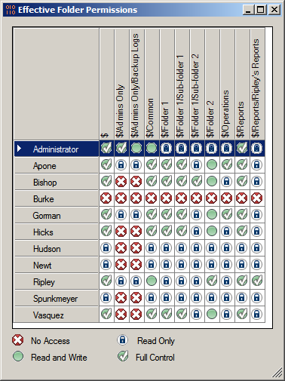

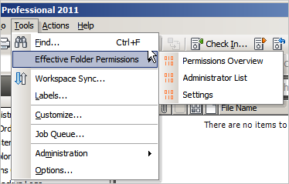

Requirements:
Vault Workgroup/Collaboration/Professional 2011
Click here to download the application
Click here to download the source code
To use:
Run the install and start Vault Explorer. There will be a new sub-menu under the tools menu and a new command in the folder context menu. You must be an administrator to run any of the commands.
If you liked this article, you might also like:
Cloaked Files
Effective Folder Permissions 1.0

